**PRACTICAL**

**AVERAGE LEARNER**

**ACTIVITY**

1. Demonstration of TeamDesk tool with functionalities.
   1. Creating a new database on TeamDesk.

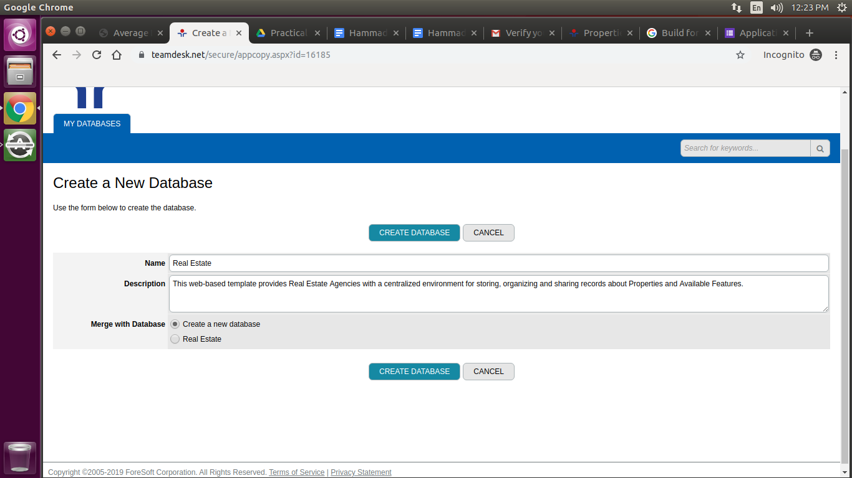

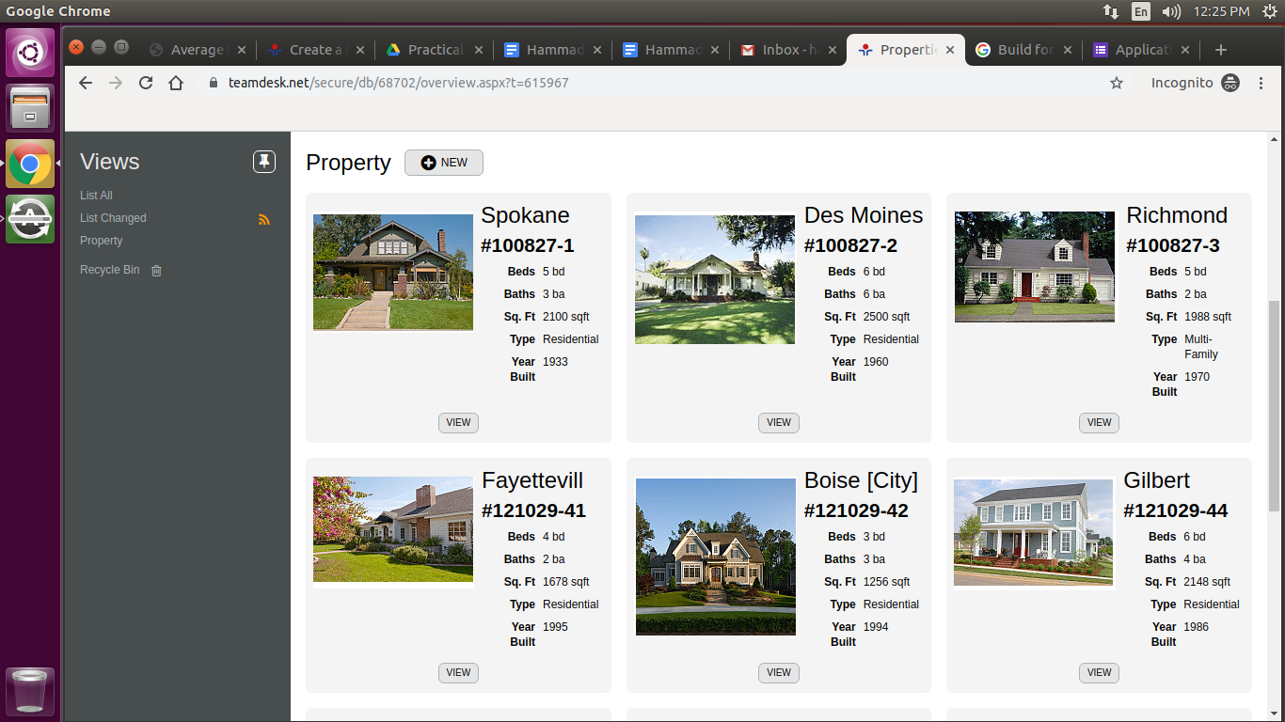

* 1. Exporting the database into CSV

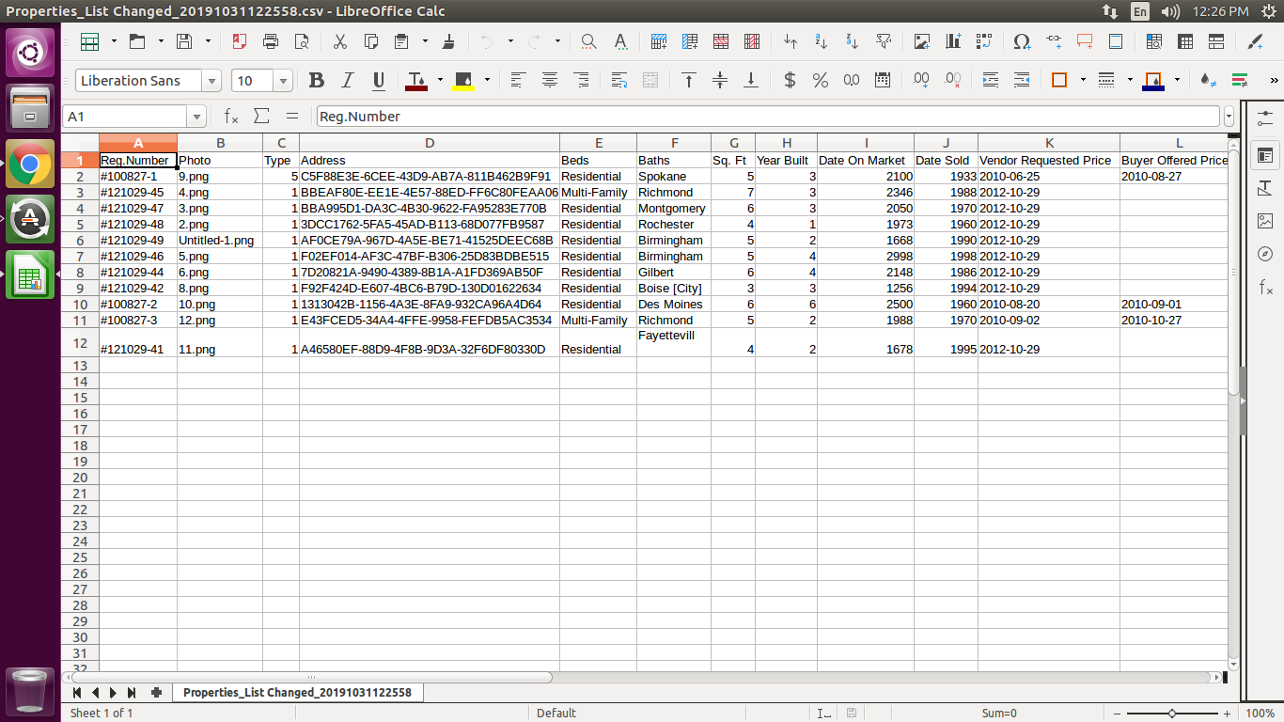

* 1. Viewing and adding similar type of data

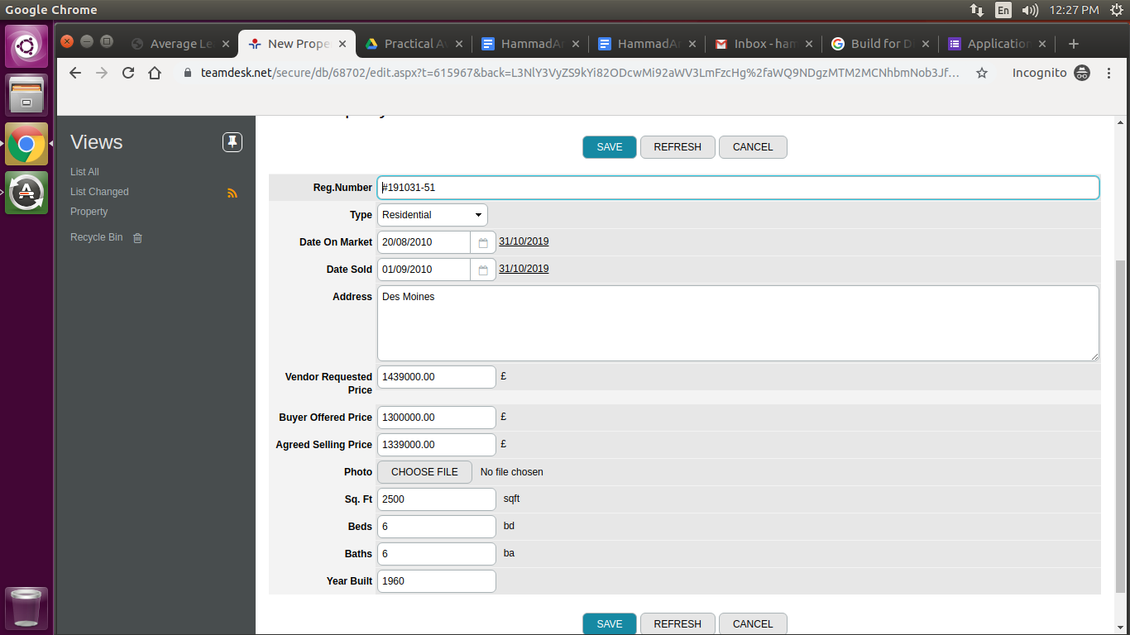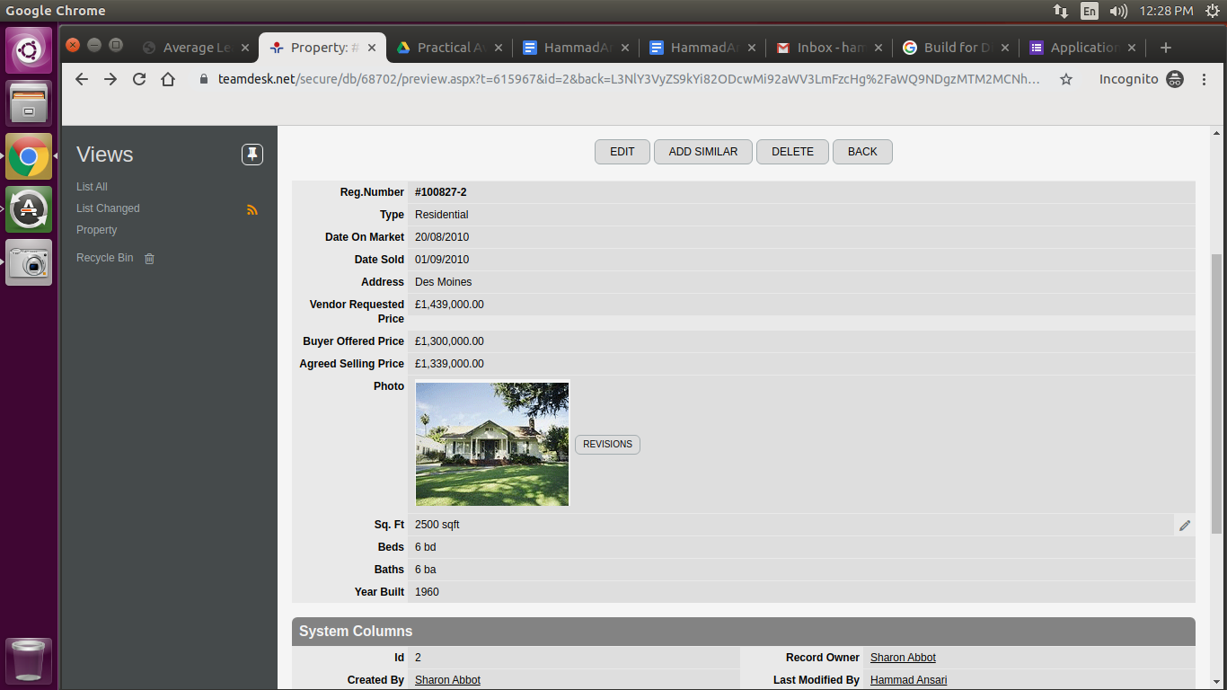

* 1. Deleting and Recovering from trash

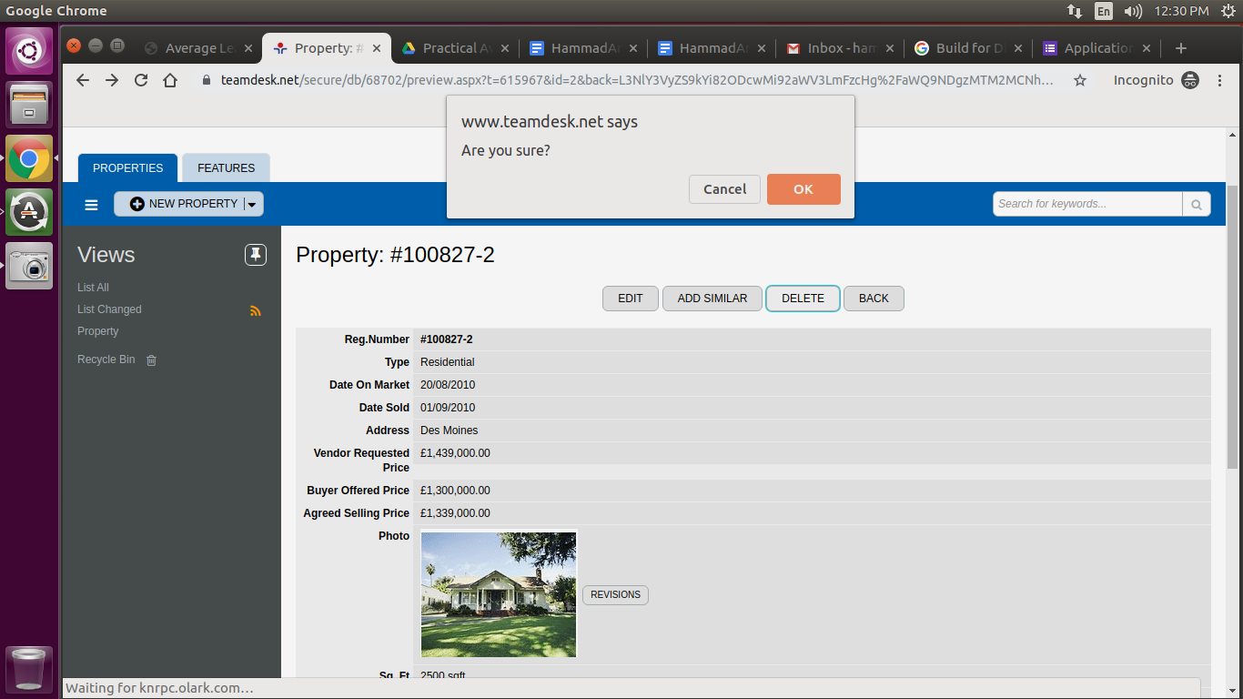

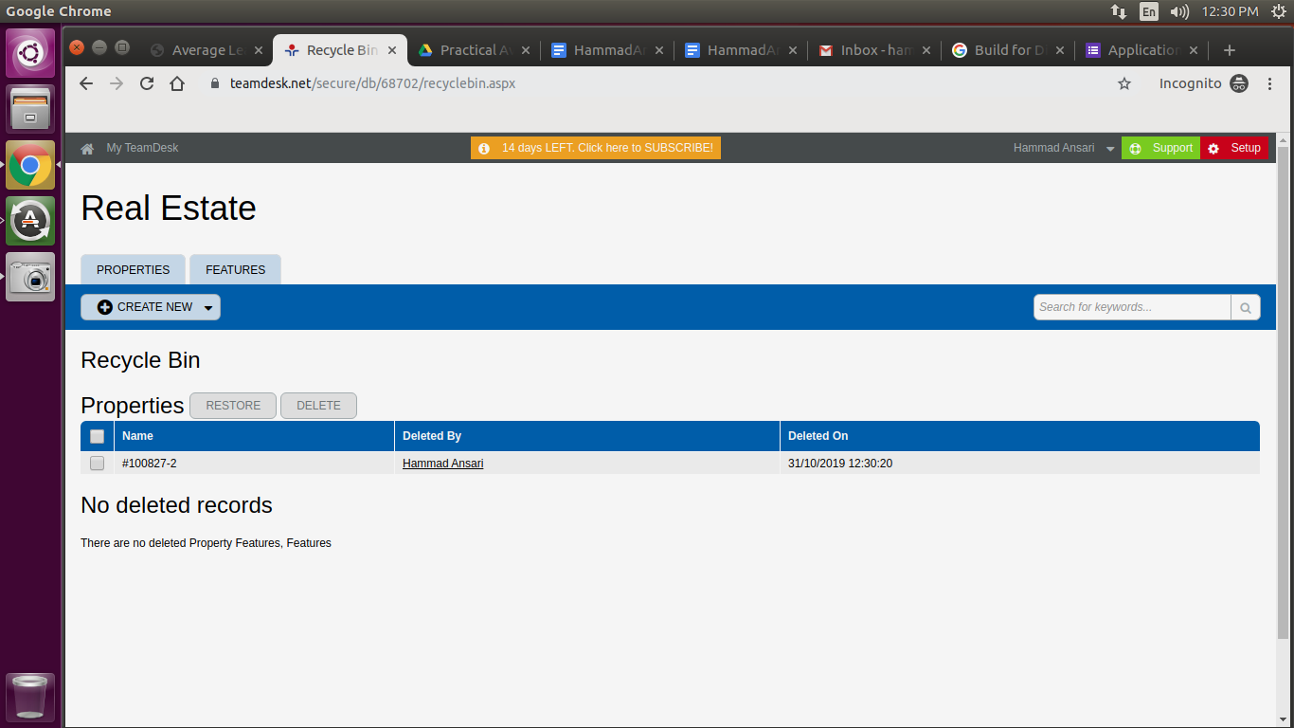

* 1. Managing roles and adding/invite different users

